Quick Guide for KEEP

Installation:

Ubuntu install Short cut:
Create a file “installkeep.sh” under installation directory
Add following code into the file
# install dependencies
sudo apt-get install git mongodb ruby rubygems npm mysql-server python-pip python-virtualenv libmysqlclient-dev libxml2-dev libxslt-dev robomongo mysql-workbench -y
sudo pip install virtualenv
sudo pip install virtualenvwrapper
sudo gem install compass
sudo npm install -g bower
sudo bower install
sudo npm install -g grunt
# get source code
git clone https://github.com/DHLabs/keep.git
cd keep
sudo npm install
# build front end
grunt build
# enable virtualenvwrapper
source /usr/local/bin/virtualenvwrapper.sh
mkvirtualenv dhlab_backend
# setup backend-environment
sudo pip install -r deps.txt
git submodule init
git submodule update
python keep_backend/manage.py syncdb
python keep_backend/manage.py migrate
fab restore_db
python keep_backend/manage.py runserver

Run the script using: ./installkeep.sh

Setting Up Your Dev Environment
Install
MongoDB ( http://docs.mongodb.org/manual/tutorial/install-mongodb-on-ubuntu/ )
MySQL ( https://help.ubuntu.com/13.10/serverguide/mysql.html )
MySQL workbench
Robomongod
Python 2.7 ( http://www.python.org )
Ruby & Rubygem (https://help.ubuntu.com/community/RubyOnRails#Get_Ruby)
Git
Python Virtual Environment
pip (http://www.pip-installer.org/en/latest/installing.html)
virtualenv ( http://pypi.python.org/pypi/virtualenv )
virtualenvwrapper ( http://www.doughellmann.com/projects/virtualenvwrapper )

sudo apt-get install git mongodb ruby rubygems npm mysql-server python-pip python-virtualenv libmysqlclient-dev libxml2-dev libxslt-dev robomongo mysql-workbench -y
sudo pip install virtualenv
sudo pip install virtualenvwrapper

Frontend Dev Environment
You must setup Frontend Dev even if you're only doing backend development. The Front-end development environment will set up the resources needed to compile and minify your frontend assets. To correctly ensure that you have a working local development environment, follow these instructions:

Install Ruby & RubyGems
After installing Ruby, run the following command to install the first set of front-end dependencies.

Install compass (an open-source CSS Authoring Framework)
gem update --system && gem install compass

Install Node.js requirements
Make sure you are in the root of the project where the package.json file is located.(Install the dependencies in the local node_modules folder.)
npm install

Install Bower Javascript/CSS dependencies
Next we make sure bower ( a javascript/css package manager ) is installed and accessible globally. You may need admin access to install globally.
sudo npm install -g bower
bower install (Using the dependencies listed in the current directory's bower.json to install packages and dependencies)

Install Grunt
Grunt is a tool to automate the repetitive tasks like minification, compilation, unit testing, linting, etc, the easier your job becomes.
sudo npm install -g grunt
Build Front-End
Finally, we used the tools we have just installed to build our javascript/css files. When the build task is completed, grunt will watch for changes in the frontend directory and rebuild when necessary.
grunt build

Backend Dev Environment
Create your development workspace
source /usr/local/bin/virtualenvwrapper.sh
(alternatively, Add this line to the end of ~/.bashrc so that the virtualenvwrapper commands are loaded.
/usr/local/bin/virtualenvwrapper.sh)
mkvirtualenv dhlab_backend
pip install -r deps.txt
Initializing Submodules
git submodule init
git submodule update

Startup MongoDB
Run mongod to ensure MongoDB is running
mongod
Setting up the Databases
The default database is mongodb + sqlite (stored in keep_backend/local.db). If you need MySQL +mongodb, then you need to edit the keep_backend/settings/defaults/database.py (before you run the command to initiate the KEEP database, you need to set up the MySQL database first, see the next section: Set up MySQL for KEEP)
Replace the following:
DATABASES = {
'default': {
'ENGINE': 'django.db.backends.sqlite3',
'NAME': 'local.sqlite',
}
}

with:
DATABASES = {
'default': {
'ENGINE': 'django.db.backends.mysql',
'NAME': 'clinic',
'USER': 'your username',
'PASSWORD': 'your password',
'HOST': 'localhost', # Or an IP Address that your DB is hosted on
'PORT': '3306',
}
}
Initiate the database
python keep_backend/manage.py syncdb
python keep_backend/manage.py migrate
fab restore_db

Note: on a syncdb command, Django will ask you to create a superuser. Create one, and use these as your login credentials for the Logging in portion.
Running the Django server
python keep_backend/manage.py runserver
Logging In
You may now log in to the system using the following credentials.
Username: admin
Password: test

Set up MySQL for KEEP:
Create a script file keepmysql.sh with following content:
echo "Please enter the username for KEEP database on Mysql :"
read usr
echo "Please enter the password for $usr"
read pwd
echo "Please enter the password of ROOT user in MySQL"
mysql -u root -p << EOF
CREATE USER "$usr"@"%" IDENTIFIED BY "$pwd";
CREATE DATABASE IF NOT EXISTS $usr;
GRANT USAGE ON $usr.* TO "$usr"@"%" IDENTIFIED BY "$pwd";
GRANT ALL PRIVILEGES ON $usr.* TO "$usr"@"%";
EOF
Run this script through ./keepmysql.sh
It will ask you to set up a Mysql database for the KEEP with dedicated username and password.

Useful software to manage database:
Robomongo
Sudo apt-get install robomongo
Mysql workbench (if using mysql to store the data)
sudo apt-get install mysql-workbench
SQLite Manager
https://addons.mozilla.org/en-US/firefox/addon/sqlite-manager/

The MySQL data structure of KEEP:
The screen shot of MySQL workbench below shows the tables in KEEP database.
auth_user store the user information
In the develop version system, the Google authenticator is not activated, neither the email authorization. If you need register a new user, you can register it in regular way, and change the value of the is_staff and is_active of the corresponding user to 1.

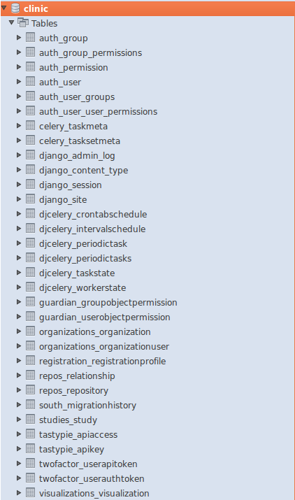

Repos_repository is the table where xforms metadata information is stored. The mongo_id the id of corresponding xform in mongodb.The actural xform data is stored in Mongodb

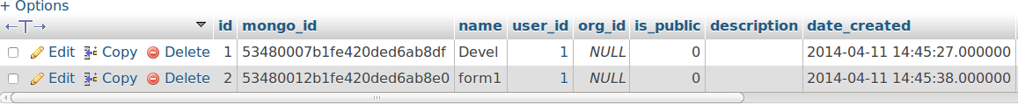

KEEP database structure in Mongodb

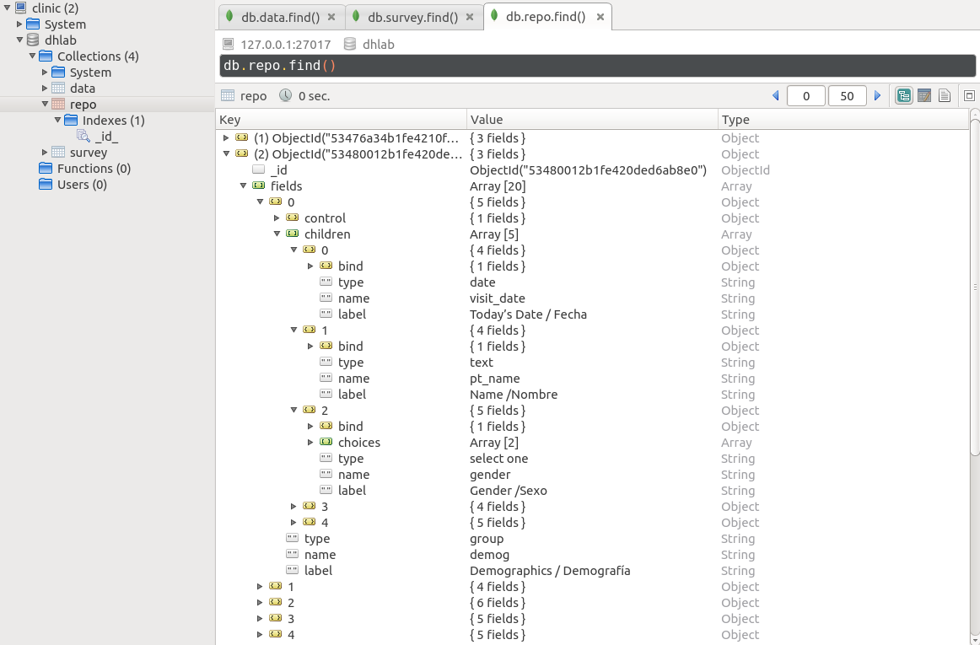
Under the collection repo, the form information of xforms is stored.
Each root object represents a form.
xform groups are stored in fields
Xform questions are stored in number objects
The input data of xforms is stored in data collection
repo indicate which xform the document is for.
Under the object data of each document, there is a list of key and value pairs, which store the user input data.

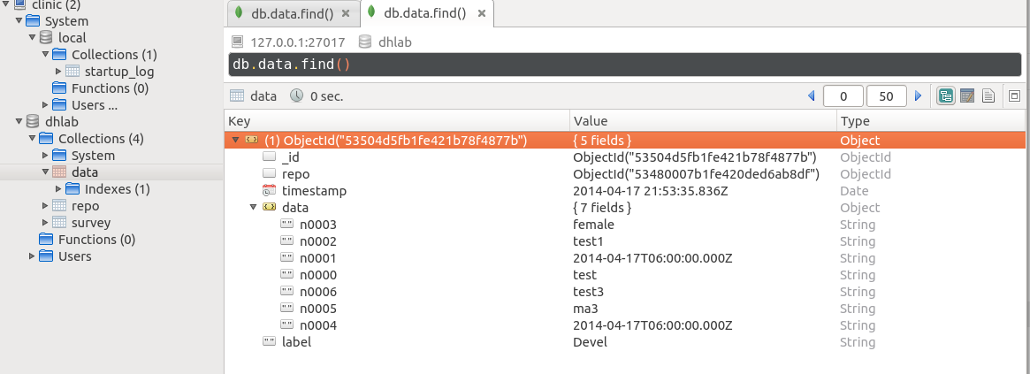
The document above is a input of the xform below:
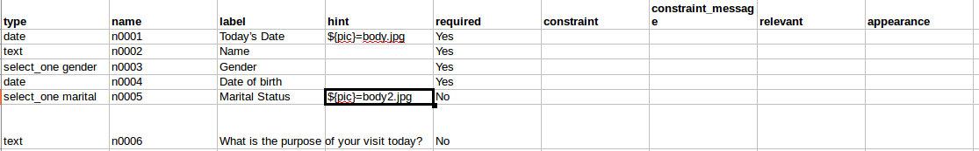
Structure of KEEP code:
Here, keep_root denotes the directory where your KEEP is installed.
For example, if you using the installkeep.sh to install the system, the keep_root=~/$input_variable/keep

The major part of KEEP is a Django app, which locates in keep_root/keep_backend

keep_root/keep_backend/templates stores the templates for main pages
index.html | 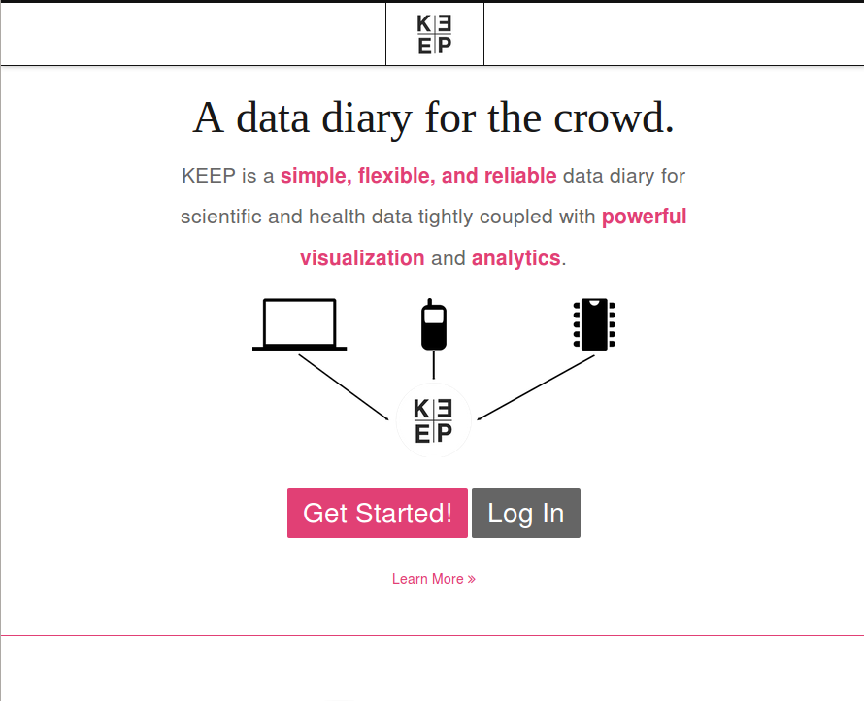
dashboard.html | 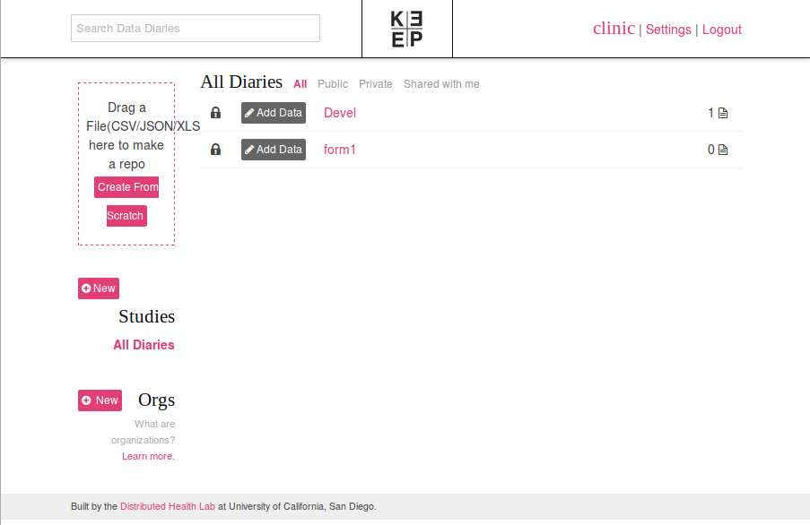
setting.html | 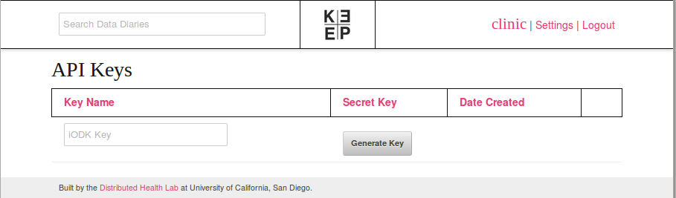

keep_root/keep_backend/static/js/app stores the js files for collection, dashboard, models, orgs, viz, and webform
These js files are generated by requirejs, monitored by grunt
The requirejs coffee scripts are stored in keep_root/frontend/coffeescript/app
If you are not familar with requirejs, and need to modify the js file directly, you need backup your modified js files. Because once you re-run grunt task, it will be overwritten by the frontend coffee script.

keep_root//keep_backend/repos stores the files to build, modify, view the repository (diaries)
views.py implements the repository functions such as, create, edit, delete
forms.py implements the functions to handle xforms

Keep_root/keep_backend/repos/templates stores the templates for repository
new.html | 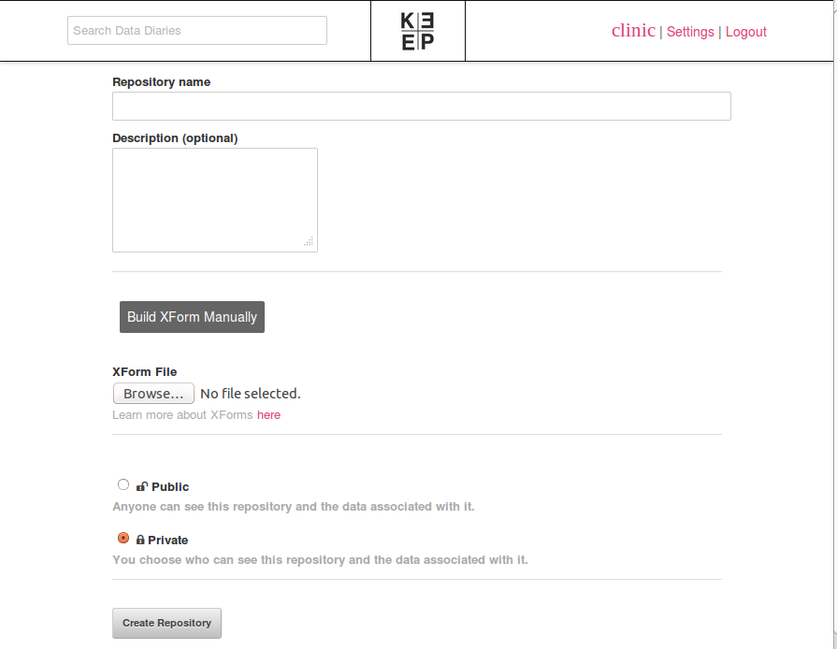
Webform.html  (add data) | 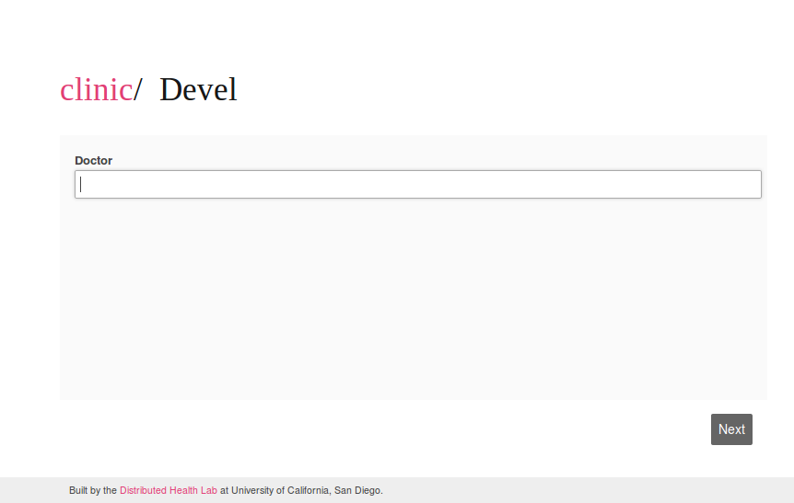
Visualize.html  (edit and view the data table of a diary) | 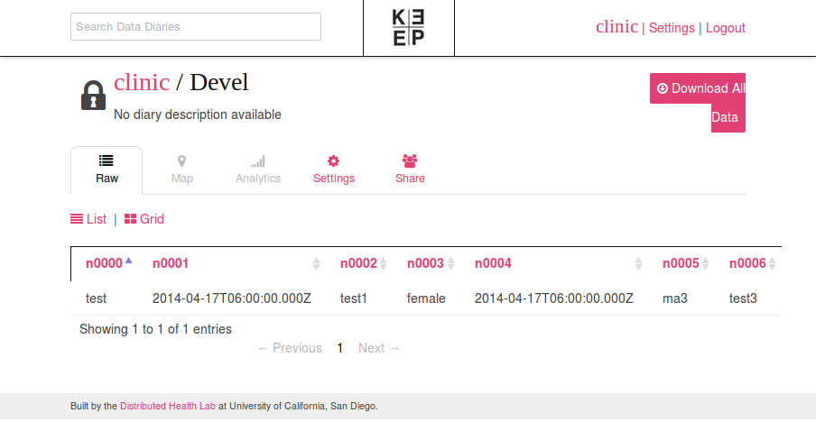

Modification of code
Implement the picture in diary
keep_root/keep_backend/static/js/app/webform/views.js

At the end of xFormView.prototype.render = function() add:

var divs=$('fieldset > div')
divs.each(function(){
var helpDiv=$(this).find('.help-block');
if(helpDiv!=undefined){
var picinfo=helpDiv.html();
if(picinfo.indexOf('${pic}=')==0){
picinfo=picinfo.substr(7);
helpDiv.html('');
helpDiv.append('<img src="../../../static/img/'+picinfo+'" />');
}
}

});

Fix the required question of xform can be skipped (doesn’t seem required)

keep_root/frontend/coffeescript/app/webform/views.coffee
change
if question.info.bind and question.info.bind.required is “yes”
to
if question.info.bind and question.info.bind.required is true

OR keep_root/keep_backend/static/js/app/webform/views.js
change
if (question.info.bind && question.info.bind.required === “yes”) {
to
if (question.info.bind && question.info.bind.required === true) {

